Angular Stpes:

==============

1. installing angular

npm install -g @angular/cli@next

2. check the angular version

ng --version

first create a folder in the desired path

open that folder path command prompt

3. create a new angular project

ng new MyApp1

H:\CGI SW REquiremenrs\Angular Demos>cd MyApp1

H:\CGI SW REquiremenrs\Angular Demos\MyApp1>code .

it will open Myapp1 project in Visual studio code.

4. execute or run angular project

ng --serve -open

ng -s o

ng serve

default port :4200

goto app.component.html

delete all content and write your own content.

Ex:

<h2> This is My Angular App</h2>

<p> I am learnig SPA using Angular</p>

goto app.component.ts

we have variable title if use want access the value of it in app.component.html. we use interpolation

goto app.component.html

<h2> Welcome to {{title}}</h2>

let us discuss about in detail about interpolation

<h3>2+ 2= {{2+2}} </h3>

<h3>2 \* 4= {{2\*4}} </h3>

<h3> {{" 2 + 2 ="+2+2 }}</h3>

<h3> {{"2+5 ="+(2+5)}}</h3>

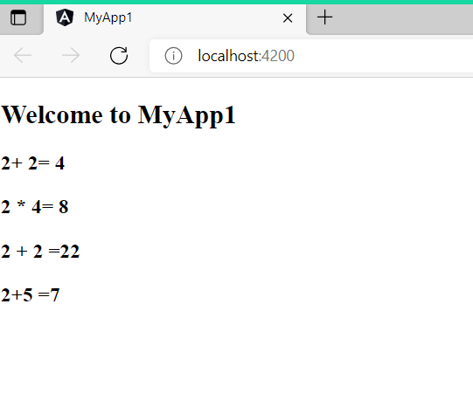

import { Component } from '@angular/core';

@Component({

  selector: 'app-root',

  templateUrl: './app.component.html',

  styleUrls: ['./app.component.css']

})

export class AppComponent {

  public name:string ="Geetha";

  public designation:string="Consultant";

  num1:number=0;

  integerNumbers:number[]=[2,45,6,78,45,34];

  title = 'MyApp1';

  ngOnInit():void{}

   greetme():any{

     return "Hello Welcome";

   }

   todaydate():any{

     return Date.now();

   }

}

<!-- <h2> This is My Angular App</h2>

<p> I am learnig SPA using Angular</p> -->

<h2> Welcome to  {{title}}</h2>

<router-outlet></router-outlet>

<h3>2+ 2= {{2+2}} </h3>

<h3>2 \* 4= {{2\*4}} </h3>

<h3> {{" 2 + 2 ="+2+2 }}</h3>

<h3> {{"2+5 ="+(2+5)}}</h3>

<h2>Name : {{name}}</h2>

<h2>  Designation : {{designation}}</h2>

<h2>  Num value  is : {{num1}}</h2>

<h2>Intergenumbers[3] = {{integerNumbers[3]}} </h2>

<h2> Current Time : {{ greetme()}}</h2>

<h2> Today Date {{ todaydate()}}</h2>

<h3>  todays date is  :{{getDate()| date:'yyyy-MM-dd'}}</h3>

<h2>  Integer array Elements are </h2>

<ul>

  <li \*ngFor="let num of integerNumbers">

    {{num}}

  </li>

</ul>

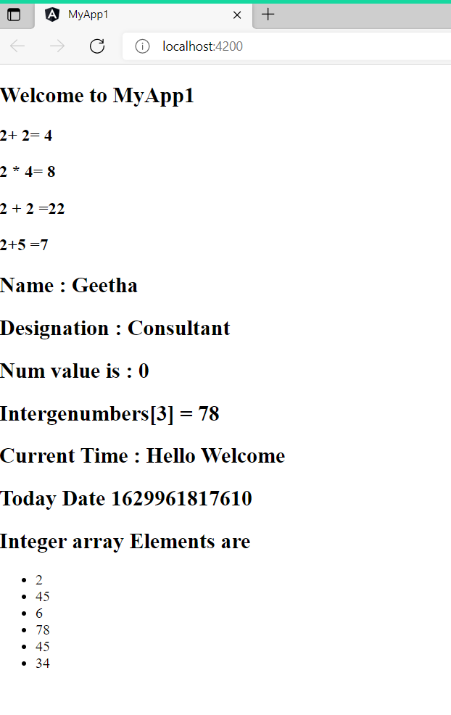

Lets us add different Component

Ng g c nav

Ng g c home

Ng g c about

ng g c --skipTests=true contact 🡺 it wont create spec.ts file

goto nav.component.html

<header>

    <div class="container">

        <a routerLink="/" class="logo">My APP </a>

        <nav>

            <li> <a routerLink="/">Home</a></li>

            <li> <a routerLink="/about">About</a></li>

            <li> <a routerLink="/contact">contact

            </a></li>

        </nav>

    </div>

</header>

App-routing-module.ts

import { NgModule } from '@angular/core';

import { RouterModule, Routes } from '@angular/router';

import { AboutComponent } from './about/about.component';

import { ContactComponent } from './contact/contact.component';

import { HomeComponent } from './home/home.component';

const routes: Routes = [

  {path:'',component:HomeComponent },

  {path:'about',component:AboutComponent},

  {path:'contact',component:ContactComponent}

];

@NgModule({

  imports: [RouterModule.forRoot(routes)],

  exports: [RouterModule]

})

export class AppRoutingModule { }

app.component.html

<app-nav></app-nav>

<section>

  <router-outlet></router-outlet>

</section>